 

GROUP MEMBERS: Warisha Khan,Rutaba Khan, Anoosha

STUDENT ID: 88341,88433,96134.

COURSE: Web -Developer

CAMPUS: Anjuman Complex Sakhi Hasan

BATCH CODE# 1603

WEBSITE**: PET CARE WEBSITE**

***PET CARE AND ADOPTION WEBSITE:***

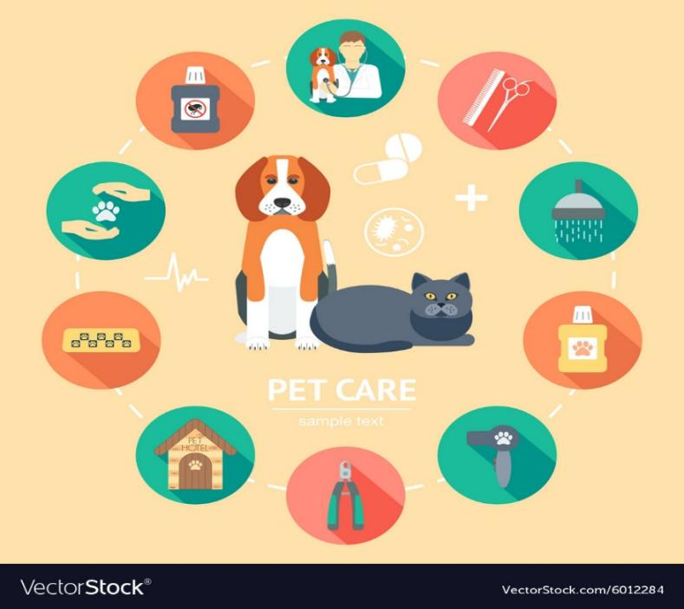

1. **Introduction:**
   * Brief overview of the website's purpose.
   * Importance of proper pet care.
2. **Basic Care:**
   * Feeding guidelines.
   * Grooming tips.
   * Housing recommendations.
3. **Health and Wellness:**
   * Common health issues and preventive measures.
   * Vaccination schedules.
   * Signs of illness.
4. **Training and Behavior:**
   * Basic obedience training.
   * Behavior troubleshooting.
   * Socialization tips.
5. **Species-specific Information:**
   * Tailor content for different pets (dogs, cats, birds, etc.).
6. **Nutrition:**
   * Dietary requirements for various pets.
   * Special dietary considerations.
7. **Emergency Preparedness:**
   * First aid for pets.
   * Emergency contacts and vet information.
8. **Interactive Features:**
   * Forums for community interaction.
   * User-submitted stories or tips.
9. **Product Recommendations:**
   * Reviews and suggestions for pet care products.
10. **Legal and Ethical Considerations:**
    * Responsible pet ownership guidelines.
    * Legal obligations for pet owners.

In the end A very big Applause for Miss Sumbul Saleem

I must say that my experience with Teacher has been exceptionally positive. In a relatively short span, she demonstrated a remarkable ability to convey complex concepts with clarity and enthusiasm, making the learning process engaging and enjoyable.